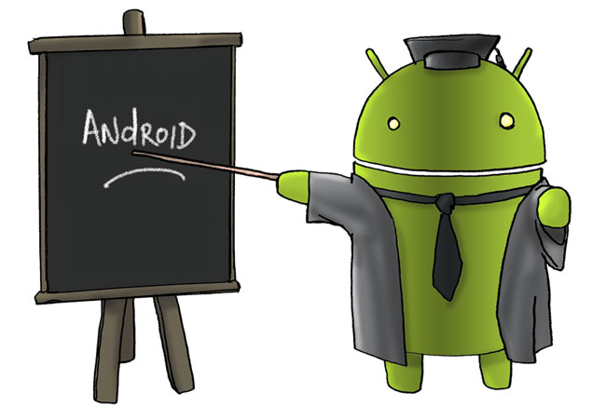BASIC ANDROID TRAINING PLAN

Version 2.0  
March 12th, 2013

Version History

|  |  |  |  |
| --- | --- | --- | --- |
| Version  # | Implemented  By | Created  Date | Reason |
| 1.0 | Nguyễn Ngọc Chiển  (FSU1-BU19-ChienNN2) | March 08th, 2013 | Create document “Basic Android training plan” |
| 2.0 | Nguyễn Ngọc Chiển  (FSU1-BU19-ChienNN2) | March 12th, 2013 | Update 2.1, 2.2, 2.3 and III |
|  |  |  |  |

Contents

**I.** **INTRODUCE** 2

1.1 Vision 2

1.2 Purpose of Basic Android training plan 2

1.3 References 2

**II.** **DEPLOYMENT SUMMARY OF TRAINING PLAN** 2

2.1 Duration 2

2.2 Teaching Methodology 2

2.3 Examination 2

**III.** **DETAIL SCHEDULE** 3

1. **INTRODUCE**
   1. Vision

There are many demands arising from customer about developments on android devices while the mobile team (BU19) can’t meet that one. Train to build an android team is necessary and long-term.

* 1. Purpose of Basic Android training plan

There are two main purposes for this training plan:

* Have enough knowledge to join android projects.
* Pass the customer’s interview.
  1. References
* Teacher: ChienNN2 (Android Developer) – appointed to teach basic android for trainees.
* Mentor: VuLT.
* Trainees: who want to join android project.

1. **DEPLOYMENT SUMMARY OF TRAINING PLAN**
2. Duration

Total time for basic course: 6 weeks (30 working days with 8 hours each day).  
In which:

+ There are first 2 weeks for basic training. They have to get knowledge about basic android and pass the exam then (all the exercises were given and all the questions will be asked face to face in the interview).

+ The 4 weeks left for the job training. They will be trained by doing the real project which has components related to the customer’s products.

1. Teaching Methodology

Apply an explicit teaching in first 2 weeks:

1. Review and answer questions (if any) in the last lesson.
2. Content-oriented lesson.
3. Deploy demo (if necessary).
4. Summarize contents being learned.
5. Suggest the objective of the next lesson.

Apply CRUM Methodology to their project in 4 weeks left.

1. Examination

There are two examinations:

* For the first 2 weeks (basic android), the requirements are:

+ complete all exercises at good rank.

+ answer at least 80% of questions well.

* For the next 4 weeks (pilot project), the requirements are:

+ Overall result of the project: reliability, availability, maintainability, portability…

+ Responsibilities of each member: present and explain every single task of them understandably.

1. **DETAIL SCHEDULE**

Basic Android  
(2 weeks)

(

Pilot Project  
(4 weeks)

(

Test

|  |  |  |  |
| --- | --- | --- | --- |
| **Lesson** | **Objectives** | **PIC** | **Duration** |
| Getting started with Android Development | • Android Features  • Android Architecture/Android software stack  • Android SDK includes developer tools, APIs, and comprehensive documentation  • Types of Android applications  • Android application component model  • Android application building blocks  • Installing the Android development environment  • Using SDK Manager and AVD Manager  • Android project structure  • Launching an Android application with different emulators corresponding different platforms  • DDMS tools  • How to debug an application  • Changing xml resource file by GUI or Text editor. | ChienNN2 | 4 hours  *(1 hour for theory*  *2 hours for practice and do exercise*  *1 hour for report)* |
| • About project structure  • How resources are used  • How Different Resources Are Referenced from Within Java and XML Files  • Some main content of the AndroidManifest.xml file  • About Fundamental Android UI Design  • About XML-based layouts  • About Handling events by using event handlers or listeners | ChienNN2 | 4 hours  *(1 hour for theory*  *2 hours for practice and do exercise*  *1 hour for report)* |
|  | | | |
| Layout Classes and Basic Views | • Design your Activity with common layout objects  • Use LinearLayout, RelativeLayout, FrameLayout, TableLayout.  • Load layout from xml-based layout file  • Create xml layout built-in source code | ChienNN2 | 4 hours  *(1 hour for theory*  *2 hours for practice and do exercise*  *1 hour for report)* |
| - Work with Basic Views:  Input Controls: Buttons, Text Fields, Check box, Radio Buttons, Toggle Buttons, Spinners, Pickers.  - Work with Basic Events:  + Event Listener.  + Event Handler.  + Touch Mode. | ChienNN2 | 4 hours  *(1 hour for theory*  *2 hours for practice and do exercise*  *1 hour for report)* |
|  |  |  |  |
| Basic Controls | - Work with Menus:  + Create an Options Menu  + Create Contextual Menus  + Create a Pop-up Menu  + Create Menu Groups  - Work with Action Bar:  + Add Action Bar  + Add Action Items  + Add Action View  + Add Action Provider  + Add Navigation Tabs  + Add Drop-down Navigation  - Work with message:  + Toast  + Dialog  + Progress Dialog  + Async Task | ChienNN2 | 8 hours  *(1 hour for theory*  *6 hours for practice and do exercise*  *1 hour for report)* |
|  |  |  |  |
| Settings and View Container | - View Container  + List View  + Grid View  + Gallery View  - Customize Adapter.  - Work with Settings:  + Define Preferences in XML  + Create Preferences Activity  + Use Preferences Fragment  + Set default values  + Use Preferences Headers  + Manage network usage  + Build a custom Preference | ChienNN2 | 8 hours  *(1 hour for theory*  *6 hours for practice and do exercise*  *1 hour for report)* |
|  |  |  |  |
| Searching and Data Saving | - Work with Searching:  + Create Search Interface  + Add recent query suggestions  + Add custom suggestion  + Searchable Configuration  - Work with Data:  + Shared Preferences  + Internal Storage  + External Storage  + SQLite Database | ChienNN2 | 8 hours  *(1 hour for theory*  *6 hours for practice and do exercise*  *1 hour for report)* |
|  |  |  |  |
| Broadcast Receiver, Audio Playback, Capturing Photos | - Work with Broadcast Receiver:  + Create Broadcast Intent  + Broadcast message between components with the send-Broadcast method.  + Listen to Broadcast Intent  + Listen to Native Broadcast  - Manage Audio Playback:  + Control your app’s volume and playback  + Manage Audio Focus  + Deal with Audio Output Hardware  - Capturing Photos:  + Take photos simply  + Record videos simply  + Control the camera | ChienNN2 | 8 hours  *(1 hour for theory*  *6 hours for practice and do exercise*  *1 hour for report)* |
|  |  |  |  |
| Content Provider and Services | - Content Provider:  + About using Content Provider to access data within other applications  + About using Content Provider to expose internal application data to other applications  - Services:  + Create, start, control, and interact with services such as started services, and bound services. | ChienNN2 | 8 hours  *(1 hour for theory*  *6 hours for practice and do exercise*  *1 hour for report)* |
|  |  |  |  |
| Network | - Send and receive data between client and server using:  + TCP  + UDP  + HTTP Get Request  + HTTP Post Request  + HttpURLConnection  + URLConnection | ChienNN2 | 8 hours  *(1 hour for theory*  *6 hours for practice and do exercise*  *1 hour for report)* |
|  |  |  |  |
| Basic Test | - Interview directly with each person. Ask them for:  + General knowledge: UI, App Resources, App Components, App Fundamentals…(on basic)  + Handling issues  + Solutions | ChienNN2 | 8 hours |
|  |  |  |  |
| Pilot Project | - Chose a leader (the best trainee).  Work in SCRUM model to build FsoTV Project.  **Grand Project – FSoTV Android**  Project description:  Create the ultimate entertainment center for users on the iPhone. Users can watch channels and videos from YouTube with your app. Users can subscribe/unsubscribe channels. For each channel, user can find information about a specific video, read comments, watch video live, or may select to record the video.  WATCH - Watch thousands of favorite shows and movies from YouTube right on your iPhone. - Tap “Live TV” to see a list of channels available to watch on your iPhone. - Tap “30’” button to go back 30 seconds when playing video  BROWSE - Browse and discover thousands of YouTube channels. - Search for videos based on categories.  RECORDINGS - Record the video for a few specific minutes for watching offline later  - Download the video to watch offline  SOCIAL - Share your favorite videos with friends on Facebook and Twitter. - Browse the top shows and videos people are currently talking about. | ChienNN2 | 160 hours |
| Total | | | 240 hours |

|  |  |  |
| --- | --- | --- |
| Approve by | Review by | Create by |
|  |  |  |
| Lê Thanh Nhàn | Lê Thanh Vũ | Nguyễn Ngọc Chiển |